Point of Sale Documentation

Instructions and Documentation for your Payment Terminal
We have put together a few important documents and instructional videos, to help you understand the basic functions of your payment terminal. The videos also walk you through how to set up your payment terminal. “CLICK ON THE PHOTO’S”

How to Set Up Ingenico's iWL255 Payment Terminal
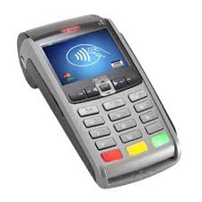

How to Set Up Ingenico's iCT250 Payment Terminal

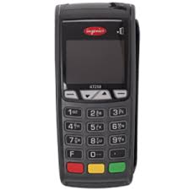

The Main Functions on Your Ingenico Payment Terminal

The Verifone 680 Functions You Need to Know
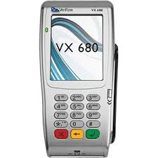

How to Set Up VX520 Payment Terminal
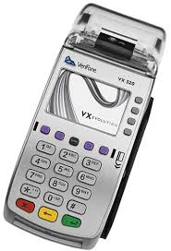

The Verifone VX520 Functions You Need to Know

Point-of-Sale Terminal Trouble-Shooting
For all troubleshooting inquiries, please contact 1 866 557-5553. A trained technician is standing by to assist you.
iWL255 - Solution Sheet
iWL252 - Solution Sheet
iCT250 - Solution Sheet
PAX S90 - Solutions Sheet
Retail - Dynamic Currency Conversion Quick - Reference Guide
Retail - Quick Reference Guide
Restaurant - Quick Reference Guide
Restaurant - Dynamic Currency Conversion - Quick Reference Guide

Terminal information, support documents and reference manuals can be found at their respective manufacturers' websites, found below:
: www.Ingenico.com

: www.verifone.com

: www.paxtechnology.us

