What is a 1099-K?
As per the IRS, all merchants must report monthly and annual gross sales by payment cards to the IRS via a 1099-K form along with their regular tax filing information.
The 1099-K form is pre-populated with the monthly and annual gross sales volume related to payment cards and is sent to the merchant on behalf of Pivotal Payments.
A copy is simultaneously sent to both the IRS and the merchant.
If you processed credit and debit card payments with Intuit in the current tax filing year, the Internal Revenue Service (under IRS regulation 6050W) may require Intuit to provide a 1099-K for your account.
Find out more about why Pivotal is providing you this form by clicking here.
Important things to know about your 1099-K:
Delivery of 1099-Ks will begin in mid-January and all required 1099-Ks will be mailed by January 31st.
Pivotal issues one 1099-K per merchant account number. All merchants that have processed credit card transactions in the tax year being reported will receive a 1099-K*.
Transactions are reported on a 1099-K are GROSS sales and do not include credits, refunds and reversals. If necessary, your accountant can help determine how to reconcile those transactions for tax purposes.
The final filling date for all 1099-K forms is April 15th of the current year however changes can only be made up to March 31st prior to that. Changes to account information can only be made to the current tax year (the year prior to the current year) and future tax year's 1099 -K unless we are specifically instructed otherwise by the IRS.
Electronic check processing transactions are not reported on the 1099-K.
If the combination of the Tax ID number (either your Employer Identification Number EIN or Social Security Number SSN) and the business legal name information on the 1099-K form do not match what the IRS has on file, a merchant is said to be in a “non-matching” status which can lead to possible fines and / or withholding of funds by the IRS.
*Certain specific merchant account types (e.g. not-for profit) may not receive a 1099-K as well as merchants that had less than 200 transactions and $20,000 in gross sales

What do I need to do with the 1099-K form?
Merchants should submit their 1099-K form along with all other documentation for their business tax filings for 2015 to the IRS.

Who is the "Filer"?
The "Filer" is the payment processor i.e. TSYS / First Data. The "Filer's" name and address information will be listed in the top left section of the 1099-K form. The "Filer's" Federal Tax ID will also be listed on the 1099-K form.
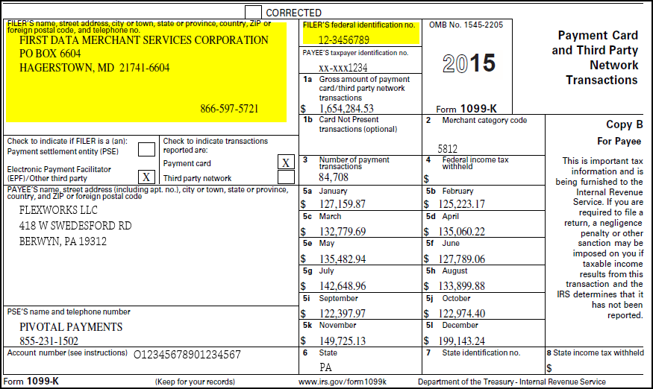

Who is the "Payee"?
The "Payee" is any person that accepts a payment card as payment, or any person who accepts payment made by a third party settlement organization on behalf of the purchaser or customer.
The "Payee's" name and address information will be listed in the middle left section of the 1099-K form. The "Payee's" Federal Tax ID (EIN or SSN) will be listed on the 1099-K form, right underneath the "Filer's" Tax ID.
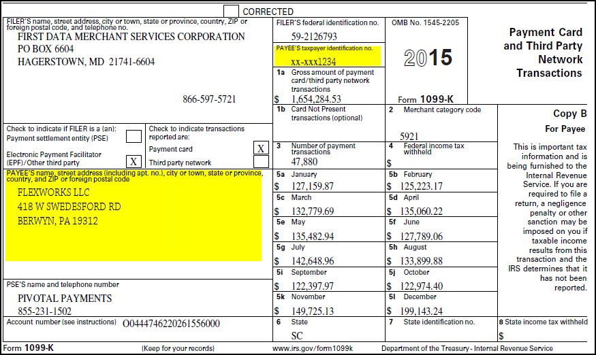

Who is the "PSE"?
The "PSE" is Payment Settlement Entity which is Pivotal Payments. The "PSE's" name and telephone will be listed in the bottom left section of the 1099-K form.
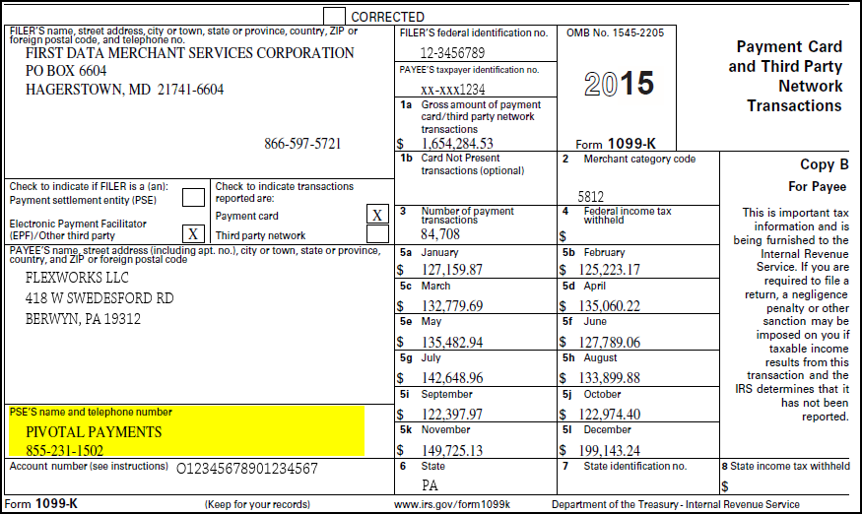

I did not receive my 1099-K or need another copy; how do I obtain another?
Merchants will have their 1099-K forms sent out during the third week or during the last week of January 2016. A copy will also be sent to the IRS.
If the merchant has not received their 1099-K form by February 20th, 2016, send an e-mail to 1099IRSTax@pivotalpayments.com.
Some merchants will receive two separate 1099-K forms, due to a change in processor or payment service provider. There may be a delay between receiving both forms in the mail.

How are the reported sales on the 1099-K form calculated?
The 1099-K form will list the gross dollar amount of payment card transactions for the 2016 tax year.
Gross dollar amount means that the dollar amounts listed on the 1099-K form are sales only. Refunds and adjustments and reversals are not counted / included.
This also means that the dollar volume totals listed on your month end paper statements may not match what is listed on the 1099-K form; the merchant's month end statement shows net dollar amounts, which means sales volume minus refunds and adjustments and reversals.
NOTE: American Express accounts that are serviced directly from American Express are not included in the totals provided by Intuit and are reported by American Express.

Where do I find the credits, refunds or reversals I processed?
You can visit the Pivotal 360 Online Service portal to view a detailed transaction report for different transaction types including refunds. www.pivotal360.com.

I changed my Business from a corporation to a Sole proprietorship. Will I receive multiple 1099-K's?
No. Only one 1099-K will be issued per merchant account that reflects information that was on file as of December 31, 2016.

When will the 1099-K form be filed with the IRS?
The final 2016 1099-K will be filed with the IRS on or before April 15, 2017, however changes will only be accepted through March 31, 2017. This will provide you the opportunity to make any corrections prior to Intuit’s final submission to the IRS.

Can 1099-K forms be filed electronically?
Yes. Those required to file may do so through the FIRE (Filing Information Returns Electronically) system. If a payment settlement entity has more than 250 individual information returns to file in any calendar year, they all must be submitted electronically. Existing users may log into FIRE. New users may create an account and test their file before submitting.

My 1099-K form was damaged or lost. Can I get another copy?
To obtain another copy of the 1099-K form, send an e-mail to 1099IRSTax@pivotalpayments.com.

What if the account information on the 1099-K is not what I want to be reported to the IRS?
Your 2016 1099-K was prepared based on the most recent account information we have on file as of December 31, 2016.
If you need to change your Business Name or Tax information, send a completed W-9 form via e-mail to 1099IRSTax@pivotalpayments.com prior to the March 31, 2017 cut-off date.

Will Business Name and Tax information changes that I make prior to March 31, 2017 be updated on the 1099-K for the IRS?
Yes. Changes made prior to March 31, 2017 will be updated on the 1099-K before the final file is sent to the IRS.

Can I make changes to a 1099-K for prior tax years (2015 or before)?
No. For prior tax year 1099-K forms, changes cannot be made. Once the final file has been transmitted to the IRS on April 15, Pivotal is unable to update any 1099-K documents for prior tax years. For further assistance, please visit IRS website, contact the IRS at 1-800-829-4933 or consult your tax professional.
Changes for the current tax year (2016) 1099-K can be made up to the final date for submission - March 31, 2017.
Additionally, you can make changes to your future (2017) 1099-K.

Why can't you change the information reported for a previous year's (2011-2015) Form 1099-K?
Once the final file has been transmitted to the IRS on April 15, Pivotal is unable to update any 1099-K documents for previous tax years (2011-2015). For further assistance, please visit the IRS website https://www.irs.gov/Businesses/Understanding-Your-1099-K, contact the IRS at 1-800-829-4933 or consult your tax professional.
Changes to your Business Name or Tax information for the current tax year’s (2016) Form 1099-K can be made up to March 31st, 2017 by sending a completed W-9 form via e-mail 1099IRSTax@pivotalpayments.com.
Please note that changes made prior to March 31, 2017 will be updated on the Form 1099-K before the final file is sent to the IRS.

How do I contact the IRS?
Please visit the IRS website or contact the IRS at 1-800-829-4933.

Will Pivotal Payments help me with my tax return?
While we’re committed to helping our merchants understand the current year tax changes, Pivotal Payments is not qualified to give you specific tax guidance. Please contact a tax professional for more assistance.

Will my E-checks be reflected in my 1099-K?
No. E-checks will not be reflected in the 1099-K.

I received a 1099-K in error and I believe I am a victim of identity theft, what do I do?
If you received a 1099-K and did not open a Payment Processing account with us or have not processed card transactions you may be the victim of identity theft. If you believe you have received a 1099-K in error and may be the victim of identity theft, please send us an email at 1099IRSTax@pivotalpayments.com

Do I have to report the amounts from the Form 1099-K on my tax return?
Please consult your tax professional or the IRS for additional information on how the amounts reported on the 1099-K should be reflected on your tax returns.

What should I do if I receive a Form 1099-K for amounts that belong to another person, or I am a co-owner who may need to file a Form 1099-K for other owners?
Please consult your tax professional or visit the IRS website at https://www.irs.gov/Businesses/Understanding-Your-1099-K for additional information.

I sold my business during the 2016 tax year. Why didn't I receive two 1099-K forms; one that reflects payments I processed and one for the payments processed by the new owner?
We only issue one Form 1099-K per merchant account. That form reflects information we have on file as of December 31, 2014. It’s recommended that you consult your tax professional, contact the IRS at (800) 829-3676 or visit https://www.irs.gov/Businesses/Understanding-Your-1099-K for further instructions and assistance.

What happens if my account information doesn't match what the IRS has on file?
If your account information does not match what the IRS has on file for your business, Pivotal Payments may be required by the IRS to assist with settlements. It is our understanding that withheld amounts can only be refunded by the IRS after you file your Federal tax returns.

How do I find out what the IRS has on file as my Business Legal Name and TIN?
Refer to your last tax return for your business or contact your tax professional.

Are purchases made with stored-value cards or gift cards reportable transactions?
It depends.
Purchases are not reportable when the card is accepted as payment by the issuer or someone who is related to the issuer of the card (such as a subsidiary company or the company itself). Under these circumstances, the stored-value cards do not fit the definition of a "payment card" and purchases made with such cards are therefore not reportable.
Purchases are reportable when the stored-value card is accepted by a network of persons unrelated to the issuer and each other.
For the definition of unrelated person see section 267(b) of the Internal Revenue Code, including the application of section 267(b) and (e)(3), or section 707(b)(1).

I own a small business and also have a not-for-profit hobby. I do not accept payment cards for payment for either, but I do use a credit card and third-party settlement organization to make purchases for both. Do the payment card reporting rules affect me?
No. The provisions for payment settlement entity reporting affect only those businesses or entities that accept these forms of payment for goods or services.
Since you do not accept these forms of payments, you will not receive a Form 1099-K for your sales.
Additionally, you will not receive a Form 1099-K for your purchases. Individuals and businesses only receive Form 1099-K for receiving payment for goods and services in reportable transactions.

Is there an IRS website that can validate that this reporting is necessary?
Yes. There is an IRS website for merchants to validate that this reporting is required by the IRS. The IRS website is: https://www.irs.gov/ .

